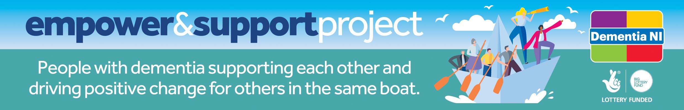

Dementia NI Engagement Request Form
Thank you for your interest in Dementia NI and in engaging with people living with dementia. Due to the sensitive and confidential nature of our work, Dementia NI must ensure a duty of care to our members, volunteers, and staff, therefore those wishing to engage will be required to agree to follow Dementia NI best practice guidelines and conditions of engagement. Dementia NI staff are available to advise on relevant guidance and support to ensure that people are working safely with and in an ethical, dementia friendly and non-compromising way with our members living with dementia.

Dementia NI is generally unable to accommodate requests to meet with specific individual members. Instead, we invite organisations/individuals wishing to consult with people with dementia, to meet with members during allocated time slots made available within the Empower and Support groups. Dementia NI Empower and Support Groups are specifically designed to provide a place where members feel safe and relaxed within a familiar environment.
Please refer to the ‘About Dementia NI’ section on our website to ensure your request tallies with the Aims, Values and Strategic direction of our organisation. Requests will not be considered until this form has been completed and returned to Dementia NI for approval.

Please complete all sections:

This form must be completed by each individual/organisation(s) who requests to work with members of Dementia NI. Request from: PLEASE TYPE HERE
Organisation: PLEASE TYPE HERE
Contact Telephone Number: PLEASE TYPE HERE
Contact Email Address: PLEASE TYPE HERE
Title of Project: PLEASE TYPE HERE
Name of Project Lead (if different from above): PLEASE TYPE HERE
Duration of Project: Start Date: PLEASE TYPE HERE End Date: PLEASE TYPE HERE
Location of Project: PLEASE TYPE HERE

Project/Activity Details:

- Dementia NI must be fully informed about the purpose of the activity/project that members will be requested to participate in. Please provide full details of the purpose of the activity/project:
PLEASE TYPE HERE
- To best utilise time spent on activity/project, please state the outcome you hope to achieve from your project and how Dementia NI members’ views will be used to improve services and support for people living with dementia in Northern Ireland. (Please list and describe the activities that are planned, goals for the partnership and who will do what):
PLEASE TYPE HERE
- Please state how Dementia NI members will be kept informed of progress made and final outcomes following the completion of the activity/project. (Please record who will evaluate effectiveness and adherence to the agreement and when evaluation will happen):
PLEASE TYPE HERE
- Please state how Dementia NI will be acknowledged and recognised as participants within this project:
PLEASE TYPE HERE

Dementia NI reserve the right to postpone or cancel planned engagement until Engagement Request Forms have been appropriately completed and approved.
Declaration:
I (Name) PLEASE TYPE HERE agree to follow Dementia NI best practice guidelines and conditions of engagement. Should my application be successful, I agree to regularly update Dementia NI on progress involving Dementia NI member engagement and agree to ‘Close the Loop’ by feedback through a final summary detailing how members’ views and contributions have been utilised.

I agree to fully acknowledge Dementia NI’s affiliation in any activities and projects relating to the engagement and will recognise Dementia NI involvement in publications and media, utilising the Dementia NI logo when appropriate, in line with Dementia NI Brand Guidelines.

I understand that a separate request form must be completed, should I wish to work with members on a project or activity not detailed on this application.

Signature: PLEASE TYPE HERE Date: PLEASE TYPE HERE

